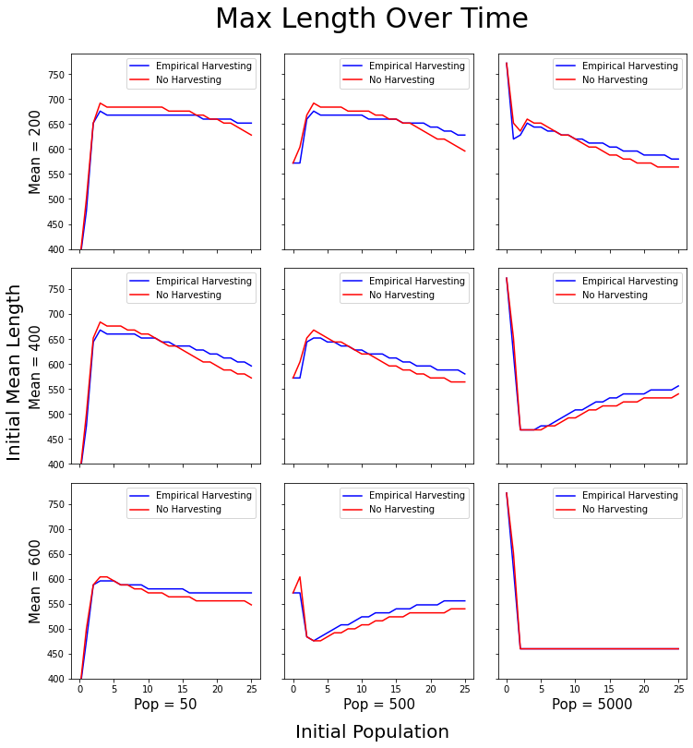

* Max length is defined as the largest bin with density > 0.0001 ‘individuals’
* At low initial densities, no harvesting shows higher max lengths as density-dependent effects are dwarfed by the harvesting of large individuals
* At higher initial densities, we see our prediction of harvesting increasing max length, as the density dependent effects are more potent
* THe apparent constant max length seen immediately in Pop =5000, Mean = 600 may be due to the population hitting maximum density early on.